Lab Report 6: OP-amp Circuit Analysis

Integrator and Differentiator Circuit Behavior
The circuit is an inverting integrator that transforms the input $1 kHz$ square wave into a triangle wave output, confirming the mathematical operation of time-integration where a constant voltage results in a linear ramp. The experimental results align with theoretical predictions, showing an inverting phase relationship where the output ramps downward during the positive half-cycle of the input. While an ideal integrator would produce perfectly linear slopes, the inclusion of the $100 kΩ$ feedback resistor $\left(R_{2}\right)$ for DC stability introduces the slight exponential curvature observed in the simulation and scope captures. This measured behavior successfully verifies the integrating functionality of the LF356 op-amp configuration.
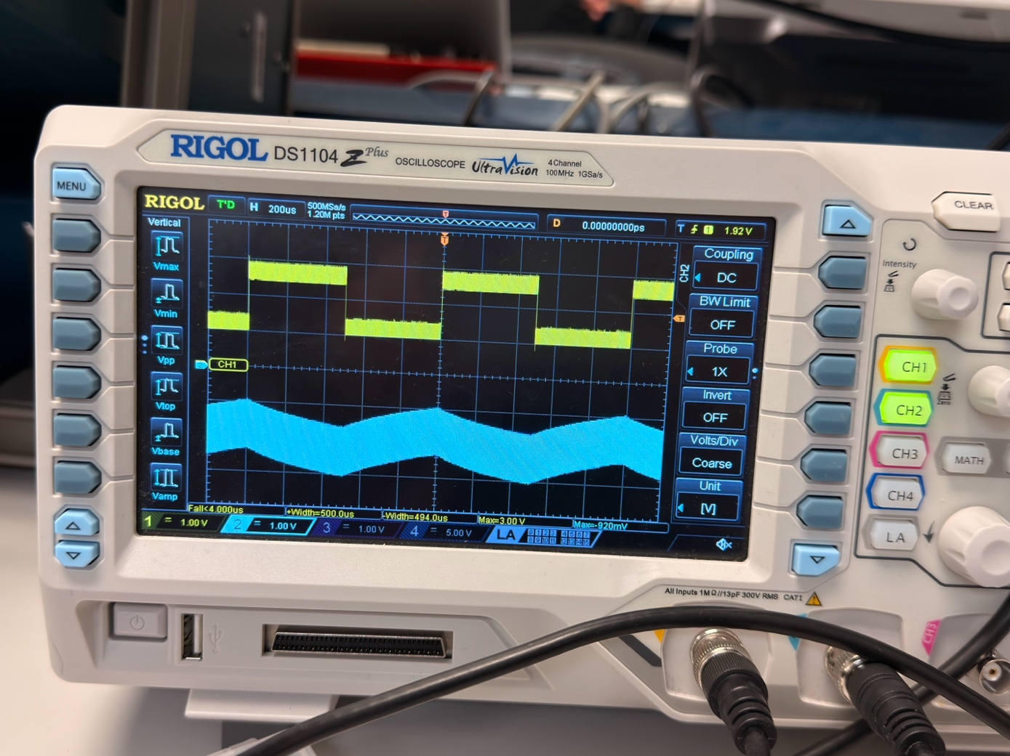
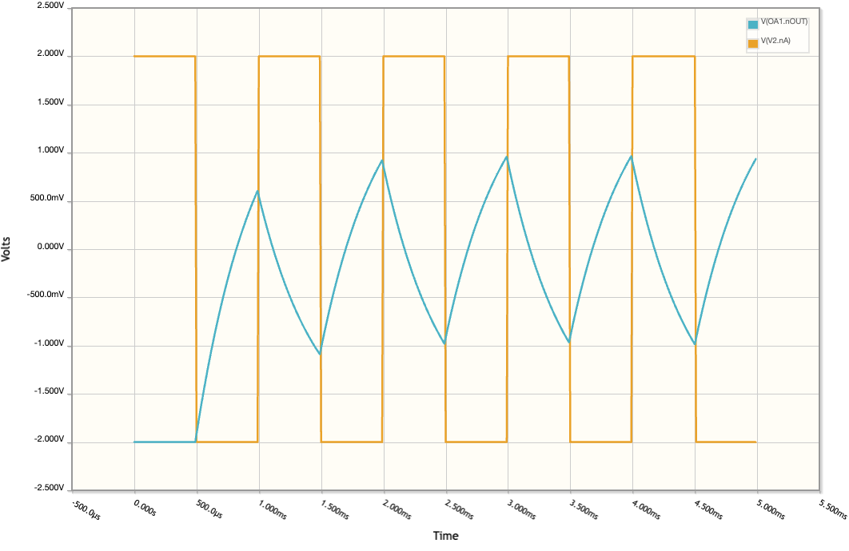
The inverting differentiator circuit successfully converts the input triangle wave into a square wave output, confirming the mathematical operation where the constant slope of a ramp results in a steady-state DC voltage. The experimental and simulation results align with theoretical predictions, showing an inverting relationship where the output jumps to a negative constant during the triangle wave's upward (positive) slope and a positive constant during the downward slope. The "spikes" or ringing observed at the transition points in both the scope and simulation are characteristic of the circuit's high-pass filter behavior, as the sudden change in slope at the triangle wave's peaks represents a high-frequency component that is heavily amplified. This measured behavior—transforming a linear ramp into a horizontal step with a $90°$ phase lead—effectively verifies the differentiating functionality of the op-amp configuration.
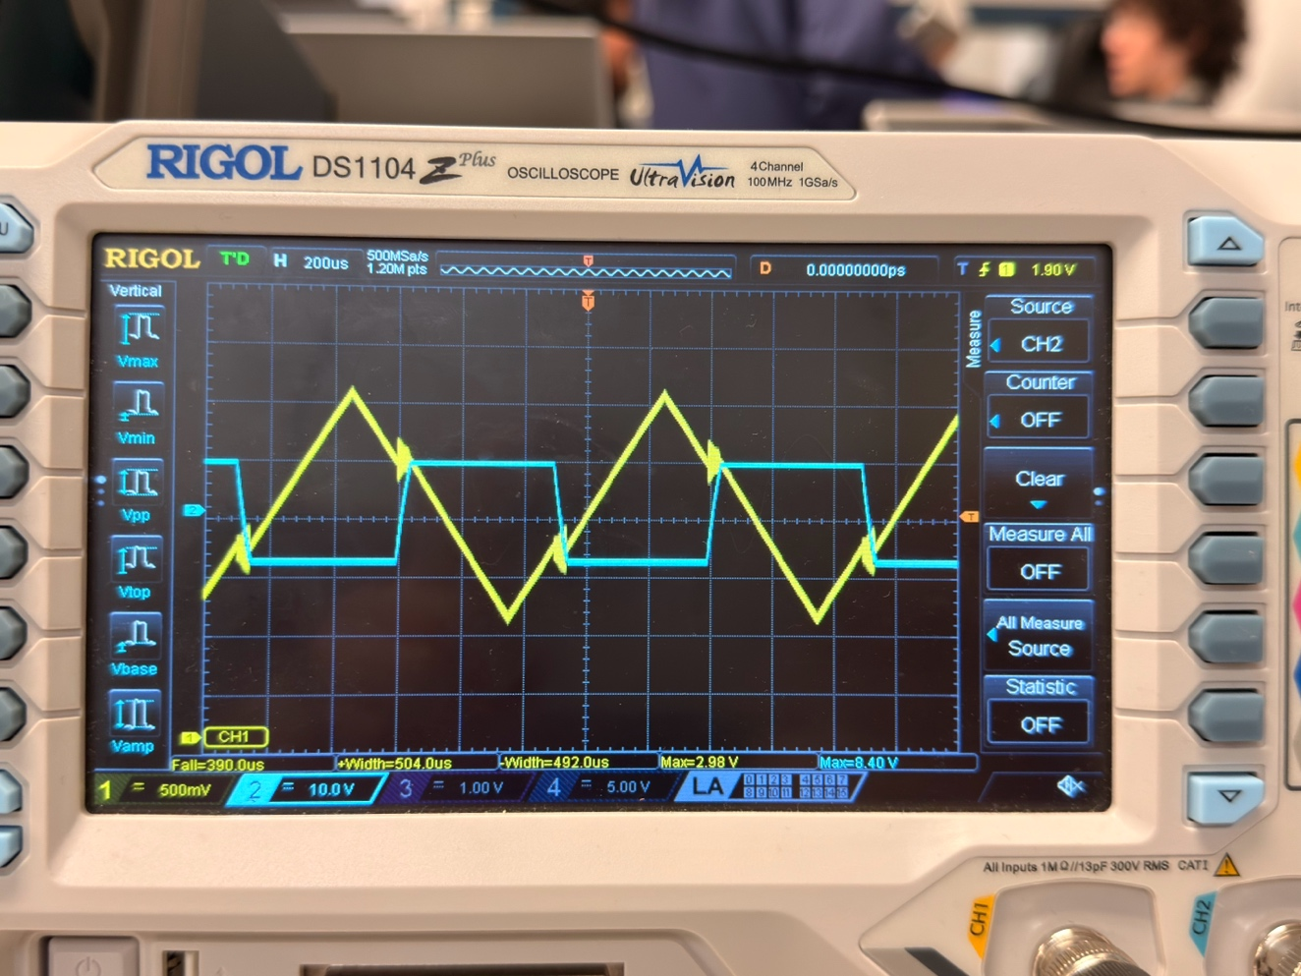
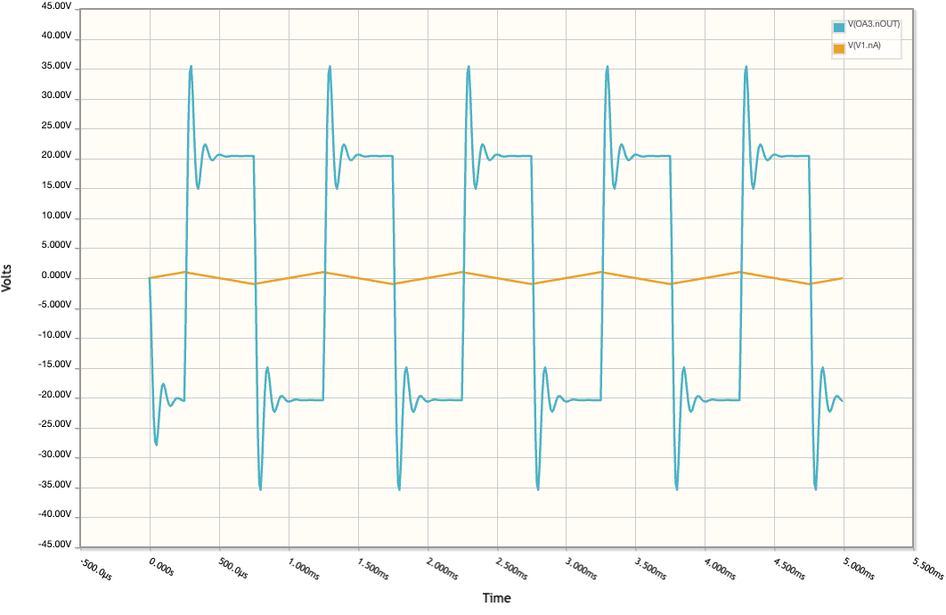

At low frequencies (below ~100 Hz), the gain is flat at approximately $0 dB$, showing that the feedback resistor $R_{2}$ successfully limits the DC gain to prevent saturation $\left(A_{v}=-R_{2}/R_{1}=-100\text{k}/100\text{k}=1\right)$. As the frequency increases, the curve hits its cutoff frequency $\left(f_{c}\right)$ at roughly $338\text{ Hz}$, where the gain begins to roll off at a constant rate of $-20\text{ dB}\text{/}\text{decade}$. This linear downward slope on the logarithmic scale represents the "integration region," where the circuit's impedance is dominated by the capacitor, effectively attenuating higher-frequency components. The "null" and subsequent rise seen around $1\text{ MHz}$ is likely due to the gain-bandwidth product (GBW) limitations and parasitic effects of the LF356 op-amp itself, indicating that the circuit loses its ideal integrating properties at extremely high frequencies.
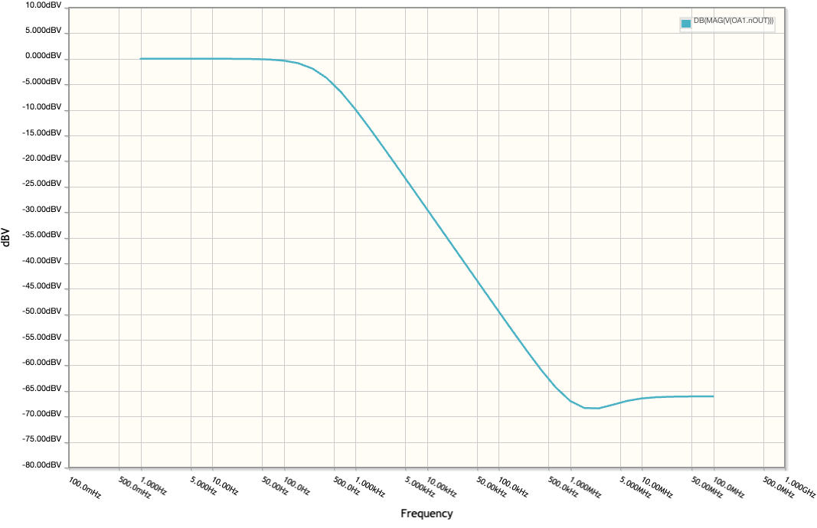

The Bode plot illustrates that the differentiator acts as a high-pass filter within its operational range, but with a critical stability limit. At frequencies below approximately , the gain increases at a constant rate of , which is the signature of a differentiator as it becomes more reactive to faster signal changes. The sharp peak at roughly represents the circuit's resonant frequency, where the open-loop gain of the LF356 op-amp meets the rising closed-loop gain, often leading to the ringing and instability seen in the previous time-domain captures. Beyond this peak, the gain rolls off steeply, indicating that the op-amp can no longer track the signal, effectively acting as a low-pass filter for high-frequency noise. This frequency response explains why the circuit excels at detecting the sharp transitions (high-frequency components) of the triangle wave but is also prone to the high-frequency oscillation (the "spikes") observed on the oscilloscope.

